SNOWFLAKE:
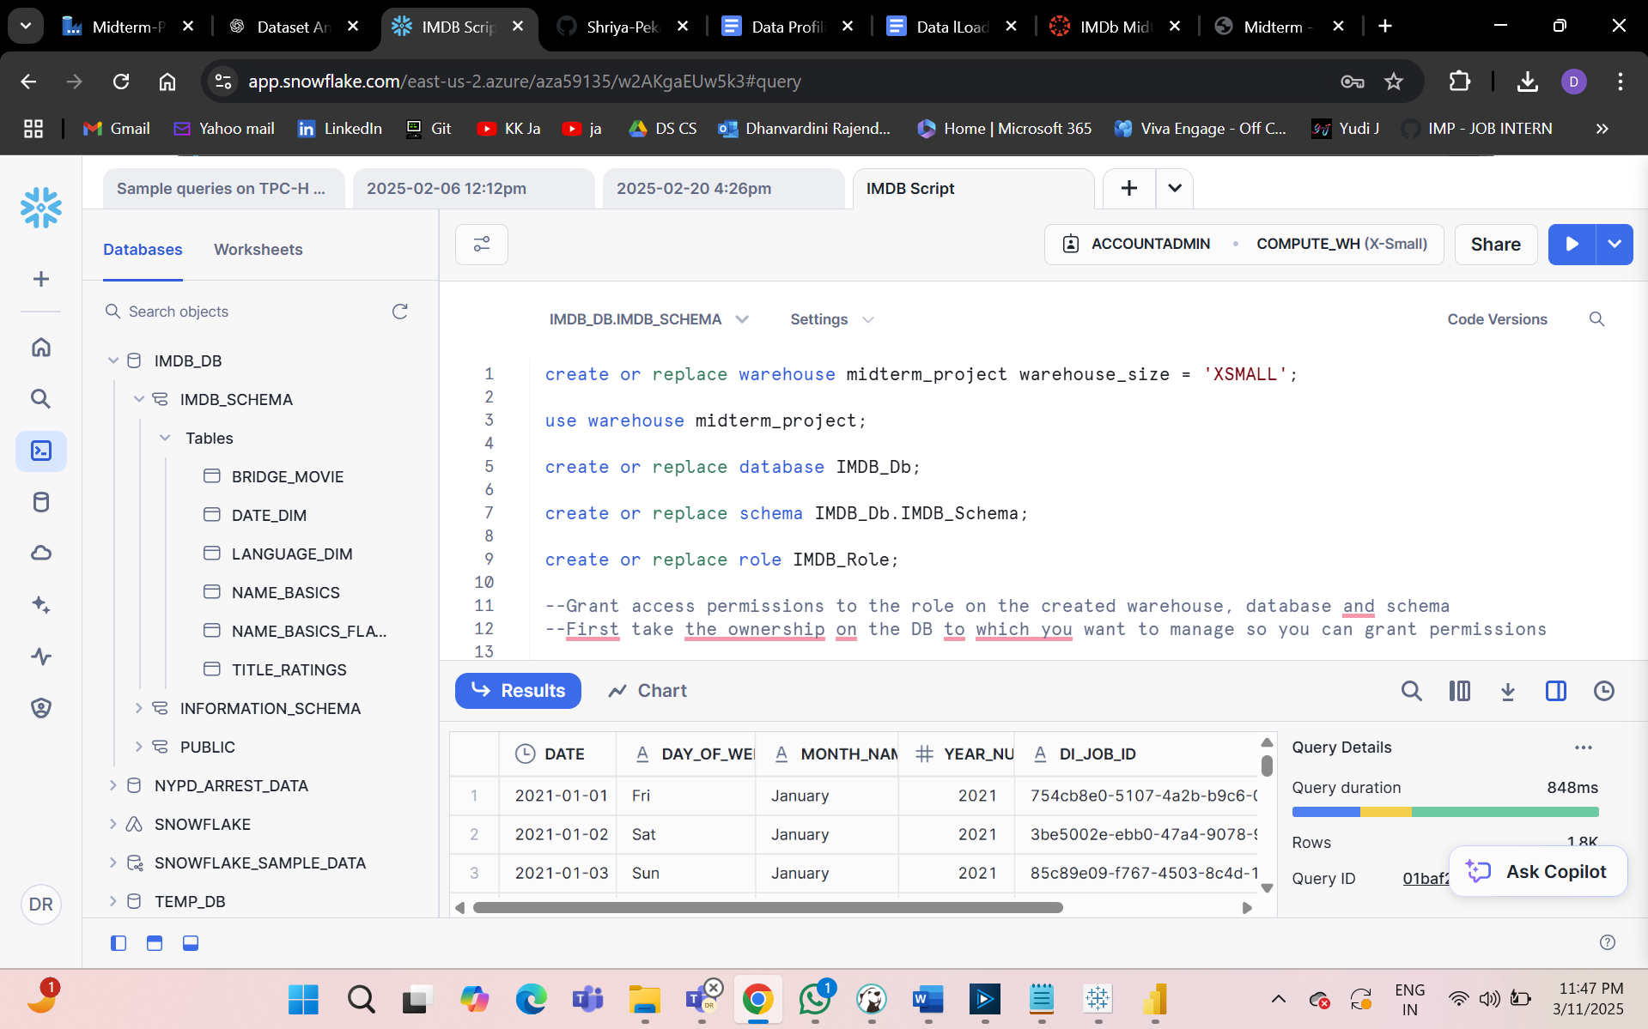

create or replace warehouse midterm_project warehouse_size = 'XSMALL';
use warehouse midterm_project;
create or replace database IMDB_Db;
create or replace schema IMDB_Db.IMDB_Schema;
create or replace role IMDB_Role;
--Grant access permissions to the role on the created warehouse, database and schema
--First take the ownership on the DB to which you want to manage so you can grant permissions
grant ownership on database IMDB_Db to role ACCOUNTADMIN;
--Warehouse
GRANT USAGE ON WAREHOUSE midterm_project TO ROLE IMDB_Role;
--DATABASE
GRANT USAGE ON DATABASE IMDB_Db TO ROLE IMDB_Role;
--SCHEMA
GRANT OWNERSHIP ON SCHEMA IMDB_Db.IMDB_Schema TO ROLE IMDB_Role;
grant usage on schema IMDB_Db.IMDB_Schema to role IMDB_Role;
--Creating user and assigning warehouse ans role
create or replace user IMDB_User password = 'snowflake123#' default_role = IMDB_Role default_warehouse = midterm_project;
--if we forgot to specify default role and warehouse for a user then we can grant them access using below commands:
grant role IMDB_Role to user IMDB_User;
GRANT ROLE IMDB_Role TO ROLE ACCOUNTADMIN;

ADF:
